Project Phase 1 Deliverables

library(tidyverse)

## ── Attaching core tidyverse packages ──────────────────────── tidyverse 2.0.0 ──  
## ✔ dplyr 1.1.4 ✔ readr 2.1.5  
## ✔ forcats 1.0.0 ✔ stringr 1.5.1  
## ✔ ggplot2 3.5.1 ✔ tibble 3.2.1  
## ✔ lubridate 1.9.3 ✔ tidyr 1.3.1  
## ✔ purrr 1.0.2   
## ── Conflicts ────────────────────────────────────────── tidyverse_conflicts() ──  
## ✖ dplyr::filter() masks stats::filter()  
## ✖ dplyr::lag() masks stats::lag()  
## ℹ Use the conflicted package (<http://conflicted.r-lib.org/>) to force all conflicts to become errors

library(tidymodels)

## ── Attaching packages ────────────────────────────────────── tidymodels 1.2.0 ──  
## ✔ broom 1.0.6 ✔ rsample 1.2.1  
## ✔ dials 1.3.0 ✔ tune 1.2.1  
## ✔ infer 1.0.7 ✔ workflows 1.1.4  
## ✔ modeldata 1.4.0 ✔ workflowsets 1.1.0  
## ✔ parsnip 1.2.1 ✔ yardstick 1.3.1  
## ✔ recipes 1.1.0   
## ── Conflicts ───────────────────────────────────────── tidymodels_conflicts() ──  
## ✖ scales::discard() masks purrr::discard()  
## ✖ dplyr::filter() masks stats::filter()  
## ✖ recipes::fixed() masks stringr::fixed()  
## ✖ dplyr::lag() masks stats::lag()  
## ✖ yardstick::spec() masks readr::spec()  
## ✖ recipes::step() masks stats::step()  
## • Use suppressPackageStartupMessages() to eliminate package startup messages

library(GGally)

## Registered S3 method overwritten by 'GGally':  
## method from   
## +.gg ggplot2

library(reshape2)

##   
## Attaching package: 'reshape2'  
##   
## The following object is masked from 'package:tidyr':  
##   
## smiths

train_data = read_csv("/Users/ellismacbookair/Library/Mobile Documents/com~apple~CloudDocs/Documents/UNCW MBA/BAN - 502 Pred Analytics/product-failure-kaggle-competition-fall-24/train.csv")

## Rows: 26570 Columns: 26  
## ── Column specification ────────────────────────────────────────────────────────  
## Delimiter: ","  
## chr (4): product_code, attribute_0, attribute_1, failure  
## dbl (22): id, loading, attribute_2, attribute_3, measurement_0, measurement_...  
##   
## ℹ Use `spec()` to retrieve the full column specification for this data.  
## ℹ Specify the column types or set `show_col_types = FALSE` to quiet this message.

str(train_data)

## spc_tbl_ [26,570 × 26] (S3: spec_tbl_df/tbl_df/tbl/data.frame)  
## $ id : num [1:26570] 0 1 2 3 4 5 6 7 8 9 ...  
## $ product_code : chr [1:26570] "A" "A" "A" "A" ...  
## $ loading : num [1:26570] 80.1 84.9 82.4 101.1 188.1 ...  
## $ attribute_0 : chr [1:26570] "material_7" "material_7" "material_7" "material_7" ...  
## $ attribute_1 : chr [1:26570] "material_8" "material_8" "material_8" "material_8" ...  
## $ attribute_2 : num [1:26570] 9 9 9 9 9 9 9 9 9 9 ...  
## $ attribute_3 : num [1:26570] 5 5 5 5 5 5 5 5 5 5 ...  
## $ measurement_0 : num [1:26570] 7 14 12 13 9 11 12 4 9 10 ...  
## $ measurement_1 : num [1:26570] 8 3 1 2 2 4 2 8 6 4 ...  
## $ measurement_2 : num [1:26570] 4 3 5 6 8 0 4 8 5 7 ...  
## $ measurement_3 : num [1:26570] 18 18.2 18.1 17.3 19.3 ...  
## $ measurement_4 : num [1:26570] 12.5 11.5 11.7 11.2 12.9 ...  
## $ measurement_5 : num [1:26570] 15.7 17.7 16.7 18.6 17 ...  
## $ measurement_6 : num [1:26570] 19.3 17.9 18.2 18.3 15.7 ...  
## $ measurement_7 : num [1:26570] 11.7 12.7 12.7 12.6 11.3 ...  
## $ measurement_8 : num [1:26570] 20.2 17.9 18.3 19.1 18.1 ...  
## $ measurement_9 : num [1:26570] 10.7 12.4 12.7 12.5 10.3 ...  
## $ measurement_10: num [1:26570] 15.9 17.9 15.6 16.3 17.1 ...  
## $ measurement_11: num [1:26570] 17.6 17.9 NA 18.4 19.9 ...  
## $ measurement_12: num [1:26570] 15.2 11.8 13.8 10 12.4 ...  
## $ measurement_13: num [1:26570] 15 14.7 16.7 15.2 16.2 ...  
## $ measurement_14: num [1:26570] NA 15.4 18.6 15.6 12.8 ...  
## $ measurement_15: num [1:26570] 13 14.4 14.1 16.2 13.2 ...  
## $ measurement_16: num [1:26570] 14.7 15.6 17.9 17.2 16.4 ...  
## $ measurement_17: num [1:26570] 764 682 663 826 580 ...  
## $ failure : chr [1:26570] "No" "No" "No" "No" ...  
## - attr(*, "spec")=  
## .. cols(  
## .. id = col_double(),  
## .. product_code = col_character(),  
## .. loading = col_double(),  
## .. attribute_0 = col_character(),  
## .. attribute_1 = col_character(),  
## .. attribute_2 = col_double(),  
## .. attribute_3 = col_double(),  
## .. measurement_0 = col_double(),  
## .. measurement_1 = col_double(),  
## .. measurement_2 = col_double(),  
## .. measurement_3 = col_double(),  
## .. measurement_4 = col_double(),  
## .. measurement_5 = col_double(),  
## .. measurement_6 = col_double(),  
## .. measurement_7 = col_double(),  
## .. measurement_8 = col_double(),  
## .. measurement_9 = col_double(),  
## .. measurement_10 = col_double(),  
## .. measurement_11 = col_double(),  
## .. measurement_12 = col_double(),  
## .. measurement_13 = col_double(),  
## .. measurement_14 = col_double(),  
## .. measurement_15 = col_double(),  
## .. measurement_16 = col_double(),  
## .. measurement_17 = col_double(),  
## .. failure = col_character()  
## .. )  
## - attr(*, "problems")=<externalptr>

# Summarize dataset  
summary(train_data)

## id product_code loading attribute_0   
## Min. : 0 Length:26570 Min. : 33.16 Length:26570   
## 1st Qu.: 6642 Class :character 1st Qu.: 99.99 Class :character   
## Median :13284 Mode :character Median :122.39 Mode :character   
## Mean :13284 Mean :127.83   
## 3rd Qu.:19927 3rd Qu.:149.15   
## Max. :26569 Max. :385.86   
## NA's :250   
## attribute_1 attribute_2 attribute_3 measurement_0   
## Length:26570 Min. :5.000 Min. :5.00 Min. : 0.000   
## Class :character 1st Qu.:6.000 1st Qu.:6.00 1st Qu.: 4.000   
## Mode :character Median :6.000 Median :8.00 Median : 7.000   
## Mean :6.754 Mean :7.24 Mean : 7.416   
## 3rd Qu.:8.000 3rd Qu.:8.00 3rd Qu.:10.000   
## Max. :9.000 Max. :9.00 Max. :29.000   
##   
## measurement_1 measurement_2 measurement_3 measurement_4   
## Min. : 0.000 Min. : 0.000 Min. :13.97 Min. : 8.008   
## 1st Qu.: 5.000 1st Qu.: 4.000 1st Qu.:17.12 1st Qu.:11.051   
## Median : 8.000 Median : 6.000 Median :17.79 Median :11.733   
## Mean : 8.233 Mean : 6.257 Mean :17.79 Mean :11.732   
## 3rd Qu.:11.000 3rd Qu.: 8.000 3rd Qu.:18.47 3rd Qu.:12.410   
## Max. :29.000 Max. :24.000 Max. :21.50 Max. :16.484   
## NA's :381 NA's :538   
## measurement_5 measurement_6 measurement_7 measurement_8   
## Min. :12.07 Min. :12.71 Min. : 7.968 Min. :15.22   
## 1st Qu.:16.44 1st Qu.:16.84 1st Qu.:11.045 1st Qu.:18.34   
## Median :17.13 Median :17.52 Median :11.712 Median :19.02   
## Mean :17.13 Mean :17.51 Mean :11.717 Mean :19.02   
## 3rd Qu.:17.80 3rd Qu.:18.18 3rd Qu.:12.391 3rd Qu.:19.71   
## Max. :21.43 Max. :21.54 Max. :15.419 Max. :23.81   
## NA's :676 NA's :796 NA's :937 NA's :1048   
## measurement_9 measurement_10 measurement_11 measurement_12   
## Min. : 7.537 Min. : 9.323 Min. :12.46 Min. : 5.167   
## 1st Qu.:10.757 1st Qu.:15.209 1st Qu.:18.17 1st Qu.:10.703   
## Median :11.430 Median :16.127 Median :19.21 Median :11.717   
## Mean :11.431 Mean :16.118 Mean :19.17 Mean :11.703   
## 3rd Qu.:12.102 3rd Qu.:17.025 3rd Qu.:20.21 3rd Qu.:12.709   
## Max. :15.412 Max. :22.479 Max. :25.64 Max. :17.663   
## NA's :1227 NA's :1300 NA's :1468 NA's :1601   
## measurement_13 measurement_14 measurement_15 measurement_16   
## Min. :10.89 Min. : 9.14 Min. : 9.104 Min. : 9.701   
## 1st Qu.:14.89 1st Qu.:15.06 1st Qu.:13.957 1st Qu.:15.268   
## Median :15.63 Median :16.04 Median :14.969 Median :16.436   
## Mean :15.65 Mean :16.05 Mean :14.996 Mean :16.461   
## 3rd Qu.:16.37 3rd Qu.:17.08 3rd Qu.:16.018 3rd Qu.:17.628   
## Max. :22.71 Max. :22.30 Max. :21.626 Max. :24.094   
## NA's :1774 NA's :1874 NA's :2009 NA's :2110   
## measurement_17 failure   
## Min. : 196.8 Length:26570   
## 1st Qu.: 619.0 Class :character   
## Median : 701.0 Mode :character   
## Mean : 701.3   
## 3rd Qu.: 784.1   
## Max. :1312.8   
## NA's :2284

# Count of failure vs no-failure  
train_data %>%  
 count(failure)

## # A tibble: 2 × 2  
## failure n  
## <chr> <int>  
## 1 No 20921  
## 2 Yes 5649

# Plot bar graph for Product Code vs Failure  
train_data %>%  
 ggplot(aes(x = failure)) +   
 geom_bar(fill = c("purple", "orange")) + # Manually assign colors to bars  
 labs(title = "Distribution of Failure Variable", x = "Failure", y = "Count") + # Add labels  
 theme_minimal(base_size = 14) # Minimal theme for clean layout

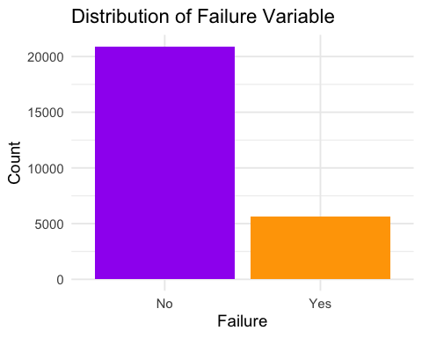

# Select continuous variables (loading and measurements)  
continuous_vars = train_data %>%  
 select(loading, starts_with("measurement"))  
  
# Calculate the correlation matrix  
corr_matrix = cor(continuous_vars, use = "complete.obs")  
  
# Convert the correlation matrix to a long format for ggplot2  
corr_long = melt(corr_matrix)  
  
# Plot the correlation matrix as a heatmap  
ggplot(corr_long, aes(x = Var1, y = Var2, fill = value)) +  
 geom_tile(color = "white") +  
 scale_fill_gradient2(low = "orange", high = "purple", mid = "white", midpoint = 0, limit = c(-1, 1), space = "Lab", name = "Correlation") +  
 geom_text(aes(label = round(value, 2)), color = "black", size = 3) +  
 theme_minimal() +  
 labs(title = "Correlation Matrix of Continuous Variables", x = "Variables", y = "Variables") +  
 theme(axis.text.x = element_text(angle = 45, hjust = 1))

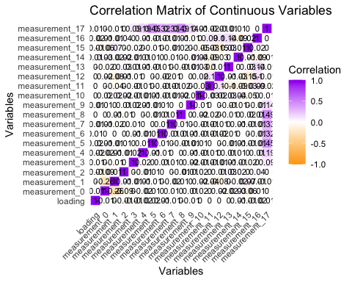

# Plot bar graph for Product Code vs Failure  
ggplot(train_data, aes(x = product_code, fill = failure)) +  
 geom_bar(position = "dodge") +  
 scale_fill_manual(values = c("Yes" = "orange", "No" = "purple")) +  
 labs(title = "Product Code vs Failure", x = "Product Code", y = "Count") +  
 theme_minimal()

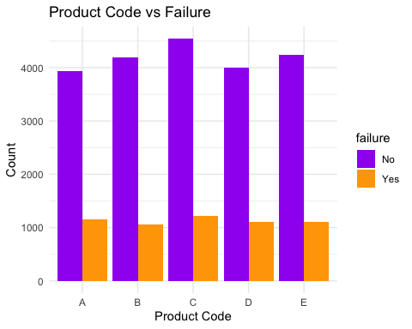

# Create the boxplot for Distribution of Loading by Failure  
ggplot(train_data, aes(x = failure, y = loading, fill = failure)) +  
 geom_boxplot() +  
 scale_fill_manual(values = c("No" = "purple", "Yes" = "orange")) +  
 labs(title = "Distribution of Loading by Failure",   
 x = "Failure",   
 y = "Loading") +  
 theme_minimal()

## Warning: Removed 250 rows containing non-finite outside the scale range  
## (`stat_boxplot()`).

